Paul’s timeline (https://www.churchofjesuschrist.org/study/scriptures/bible-maps/map-13?lang=eng#figure1_p55)

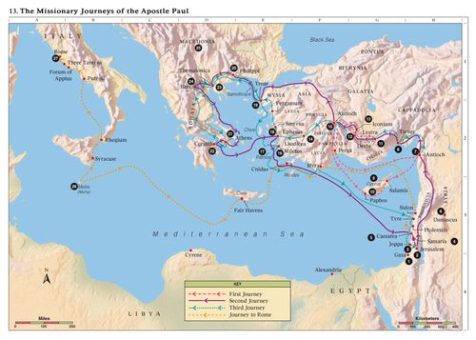

1. Jerusalem: The clothes of Stephen are laid at the feet of Stephen (Acts 7:54-60)
2. Gaza: Paul baptizes an Ethiopian Eunuch (Acts 8:26-39)
3. Damascus: Jesus appears unto Paul; Paul is baptized and begins his ministry (Acts 9:1-10;10-27)
4. Antioch: Paul begins his second mission with Silas, Barnabas, and Judas Barsabas (Acts 15:22)
5. Tarsus: Paul’s hometown; paul is sent here to protect his life (Acts 9:29-30)
6. Cyprus: Paul traveled through cyprus on his first missionary journey (Acts 13:4-5)
7. Paphos: Paul curses a sorcerer (Acts 13:6-11)
8. Lystra: Paul heals a cripple. He is stoned and is thought to be dead. However, he rises up and continues on to Derbe. (Acts 14:6-21)
9. Iconium: Paula and Barnabas preach and are threatened with being stoned during their first mission (Acts 13:51-14:7)
10. Miletus: Paul warns the elders of the Church that “grievous wolves” would enter the flock (Acts 20:29-31)
11. Ephesus: Paul taught in Ephesus for two years during his third mission. He conferred the Gift of the Holy Ghost by the laying on of hands (Acts 19:1-7). Worshippers of Diana fought against Paul